|  |  |
| --- | --- |
| **HomeController** | |
| **Physical address** | admin/application/controllers |
| **Base class** |  |
| **Attributes** | |
| N/A | |
| **Operations** | |
| index() | |
| **Return Type** | void |
| **Parameters** | N/A |

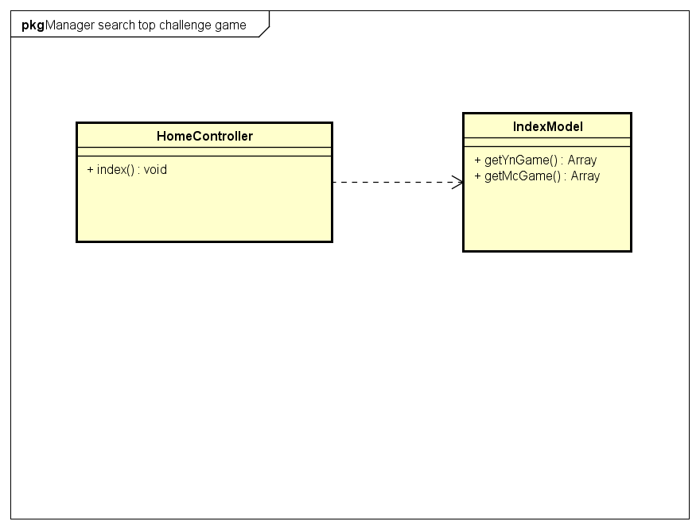

|  |  |
| --- | --- |
| **IndexModel** | |
| **Physical address** | admin/application/models |
| **Base class** |  |
| **Attributes** | |
| N/A | |
| **Operations** | |
| getYNGame() | |
| **Return type** | Array |
| **Parameters** | **N/A** |
| getMCGame() | |
| **Return type** | Array |
| **Parameters** | **N/A** |
| getChampion() | |
| **Return type** | Array |
| **Parameters** | **N/A** |
|  |  |